**2024/2025 YEARLY PLANNING GUIDE**

|  |
| --- |
| **CLUB NAME:** |
| **CLUB LEADS + EXECS:** |
| **CLUB MISSION + VISION:** |

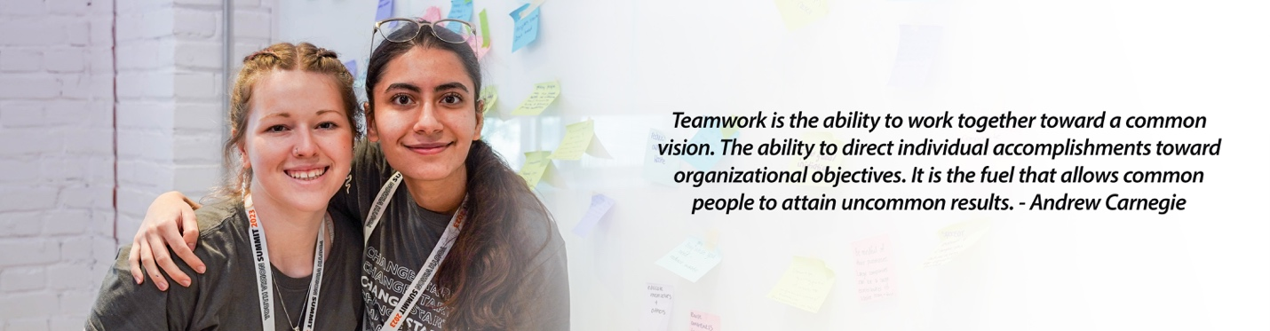

**SETTING GOALS:**   
Outline measurable goals that will lead your club towards achieving your vision. Goal setting is a crucial step to develop a strategic plan for the year and ensure your team is on the same page regarding expectations, objectives, and delegation. Having these goals written out is important to build accountability within the team to complete the tasks and execute events within the decided time. At the same time, it is important to allow for flexibility in your annual goals to account for busier times of the year such as exams. Your goals need to be SMART – Specific, Measurable, Achievable, Relevant, and Time-Bound. (*Check out more information on* [***setting SMART goals***](https://www.atlassian.com/blog/productivity/how-to-write-smart-goals#:~:text=An%20example%20of%20a%20SMART,will%20%5Bresult%20or%20benefit%5D.)*.*

**FUNDRAISING GOALS:**   
*[Check out* ***[World Vision gift catalogue](http://www.worldvision.ca/gift)*** *for donation options]*

* *E.g Planning two campus-wide fundraising events to raise $320 by first semester to donate* [***2 beehives and 2 beekeeping kits***](https://donate.worldvision.ca/products/beehives-and-beekeeping-kits) *to provide small business opportunities for vulnerable communities in rural Tanzania*
* [Add Goal]
* [Add Goal]
* [Add Goal]

**EDUCATION/ AWARENESS GOALS:**

* *E.g Run a club information booth each semester at the Student Activity Centre to talk to at least 30 students about world hunger and invite them to sign the World Vision Canada* [***ENOUGH pledge***](https://act.newmode.net/action/world-vision-canada/sign-our-pledge-help-stop-hunger)
* [Add Goal]
* [Add Goal]
* [Add Goal]

**ADVOCACY GOALS:**

* *E.g Host a letter writing session in October around World Food Day (October 16th) to gather students to write to local MPs about World Vision’s* [***ENOUGH advocacy campaign***](http://www.worldvision.ca/enough) *and ask the government to make a Canada-led school meals policy commitment for the most vulnerable girls and boys in the 2024 G20 summit.*
* [Add Goal]
* [Add Goal]
* [Add Goal]

**TEAM AND COMMUNITY BUILDING GOALS:**

* *E.g Build an online newsletter by January with at least 30 subscribers, sending general members monthly email updates about chapter events and campaigns.*
* [Add Goal]
* [Add Goal]
* [Add Goal]

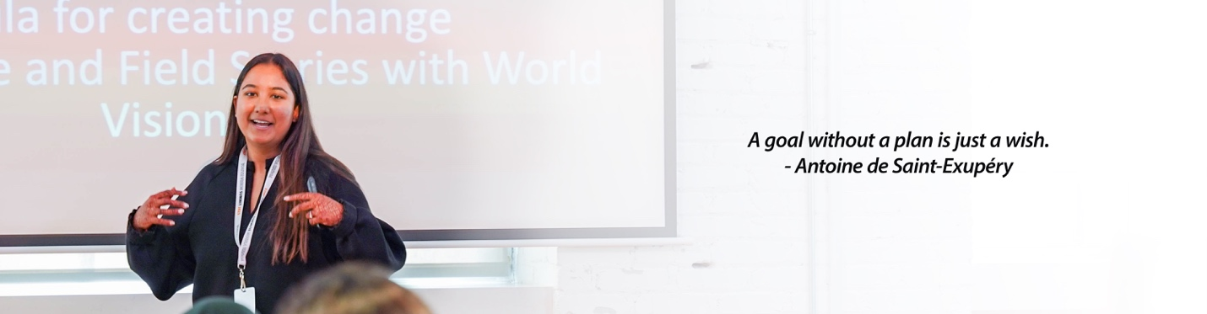

**Timeline:** *Populate this table with your events and activities for the year.*

|  |  |  |
| --- | --- | --- |
|  | **Key Dates** | **Events and Activities** |
| Sep 2024 | Sep 21 – International Day of Peace | *E.g. Clubs Society Day, Exec and General Members Recruitment* |
| Oct 2024 | October is Women’s History Month  Oct 10 – World Mental Health Day  Oct 11 – International Day of the Girl child  Oct 16 – World Food Day  Oct 17 – International Day for the Eradication of Poverty | *E.g. World Food Day Awareness Raising* |
| Nov 2024 | Nov 11 – Remembrance Day  Nov 25 – International Day of Elimination of Violence against Women | *E.g. G20 Global Hunger Advocacy Campaign with World Vision Canada* |
| Dec 2024 | Dec 10 – Human Rights Day  Dec 25 – Christmas  Dec 25 to Jan 1 – Hanukkah | *E.g. Christmas Exec Team Party* |
| Jan 2025 | Jan 1 – New Year  Jan 24 – International Day of Education  Jan 26 – Bell Let’s Talk Day | *E.g. Clubs Society Day + Cinnabon Sale* |
| Feb 2025 | February is Black History Month  Feb 20 – World Day of Social Justice | *E.g. Valentines Day FairTrade Chocolate Fundraiser* |
| March 2025 | Mar 8 – International Women’s Day  Mar 22 – World Water Day | *E.g. Student Pub Night Fundraiser* |
| April 2025 | April 7 – World Health Day  April 22 – Earth Day | *E.g. Annual General Meeting / Year End Celebration Party, President Election / Selection* |